**LVA**

**En vous appuyant uniquement sur les documents du dossier thématique qui vous est proposé, vous rédigerez une synthèse répondant à la question suivante :**

***What is at stake with the current housing crisis in the US?***

**Votre synthèse comportera entre 450 et 500 mots et sera précédée d'un titre. Le nombre de mots rédigés (titre inclus) devra être indiqué à la fin de votre copie.**

**Document 1 - Here’s What Harris and Trump Have Proposed to Help the Housing Crisis**

*Time.com*, by Rebecca Schneid, September 11, 2024

[…] Both candidates have talked about housing on the campaign trail. Harris released a recent 60-second ad on economic policy, focused primarily on housing and first-time homeownership, which outlines parts of her plan, including building new homes and providing down payment assistance. Trump, meanwhile, has vowed to reduce regulatory hurdles to building new homes, among other ideas.

“We have never seen that before in a presidential debate between two major candidates, and certainly we're hearing about housing affordability in elections at all levels, federal, state and local, far more than we have previously,” says Diane Yentel, President and CEO of the National Low Income Housing Coalition. “It's a reflection both of how severe the housing affordability crisis has become and also of the organizing that’s putting pressure on politicians to respond.”

According to Brian McCabe, Associate Professor of Sociology at Georgetown, housing affordability is not a new issue, particularly for the lowest income Americans renting without rental assistance or a voucher, and those utilizing public housing. But the current spotlight on the issue is at least in part due to affordability issues increasingly trickling upward to more middle-class Americans who are “politically really important for both parties.”

“This is hitting first time homebuyers that can't get into the housing market. This is hitting middle class renters who are spending more than 50% of their income on rent,” says McCabe. “It’s not that there's never been an affordability crisis before, but it's now an affordability crisis that's hitting a much broader set of Americans.” […]

Earlier this year, the Biden Administration announced a series of policy proposals that deployed a public-private approach focused on changing exclusionary zoning, expanding the financing options for affordable housing, and promoting the conversion of empty office space into apartments. […]

Harris’s plan largely focuses on the supply side of the problem, promising to “work with the private sector and home builders to… increase by 3 million homes by the end of my first term,” to address the housing shortage, she said in the debate.

The federal government has “pretty limited muscle to actually move housing supply,” says McCabe, considering that regulatory burdens like zoning or building codes are usually at the local level.

Harris’ plan also includes expansion of the low-income housing tax credit (LIHTC) and additional tax incentives for builders to produce more “starter homes,” as well as creating a $40 billion tax credit to make affordable projects feasible for builders.

On the demand side, Harris has said she would provide $25,000 in down-payment assistance for first-time home buyers if elected. […]

During a speech earlier this month to the Economic Club of New York, [Trump] promised to reduce regulations and open swaths of federal land for large-scale housing construction. […] It’s not clear what types of regulations Trump wants to target, though taking a look at federal land may be a bipartisan solution: President Joe Biden called on federal agencies in July to “to assess surplus federal land that can be repurposed to build more affordable housing across the country.” […]

**Document 2 - Renters are struggling more than homeowners in America’s tough housing market, report says**

*CNN*, June 23, 2024, by Bryan Mena

Homeowners in America aren’t the only ones struggling with an unaffordable housing market. Renters are also bearing the brunt.

A report from Harvard University’s Joint Center for Housing Studies released last week showed that both homeowners and renters in recent years have become increasingly burdened by climbing housing costs. The report, based on an analysis of existing data, said that nearly one in four households that own a home “are now stretched worryingly thin.” The cost burdens are even worse for renters.

“For renters, the landscape is even more challenging,” the Harvard report said. “While rents have been rising faster than incomes for decades, the pandemic-era rent surge produced an unprecedented affordability crisis.”

Renters who spend more than half of their household income on housing and utilities rose in 2022 to a new record high of 12.1 million, up 1.5 million from levels seen before the Covid-19 pandemic. Allocating such a high proportion of household income to rent makes them vulnerable to becoming unhoused if they face an unexpected financial issue, such as an unexpected medical bill.

That’s all part of a broader struggle in the US housing market, and recent data shows that it hasn’t gotten any better. A persistent lack of homes available for sale is spurring bidding wars. Elevated mortgage rates are keeping sellers and some buyers on the sidelines.

“Housing costs are a particular pain point for American households,” Lael Brainard, director of the White House’s National Economic Council, said Thursday at an event in Washington.

“Congress really does need to act here,” she said. “The Senate could act tomorrow and we would have tax credits for 200,000 additional affordable units,” referring to a bill that recently passed the US House.

Speaking at an event hosted by the Urban Institute, Brainard outlined the Biden administration’s attempts to fix America’s housing market, such as a cap on annual rent increases for the 2 million households in “low-income housing tax credit” units and a reduction in Federal Housing Administration mortgage insurance premiums that took effect in the spring.

“Already, nearly 700,000 homeowners are saving roughly $900 annually as a result of the Administration’s reduction in mortgage interest premiums for FHA-backed loans,” Brainard said.

The Harvard report said that “state and local experimentation with regulatory reforms and incentives will incrementally add affordable homes” and that there’s a pressing “need for down payment support and access to low-interest mortgage products to close racial gaps and put homeownership within reach for households with modest incomes.”

**Document 3 – America’s Affordable Housing Crisis**

*The New York Times*, by Conor Dougherty, March 27, 2024

President Biden worries about high housing costs. So do Republicans in Congress. The consensus reflects a major problem: Tens of millions of families, across red and blue states, struggle with rent and home prices. The reason is a longstanding housing shortage.

But action in Washington won’t make a huge difference. America’s affordable housing crisis is likely to be solved in cities and states. […]

Home prices are up about 60 percent over the past decade, adjusted for inflation. About a quarter of renters — some 12 million households — spend more than half their income on housing, far in excess of the one-third level that is considered healthy. Homeless camps have expanded, and “super commuters” — who drive for 90 minutes or longer to work — have migrated well beyond the expensive coasts to smaller cities […], and fast-growing metropolitan areas […] .

Generally, Republican-led states have been more affordable than Democratic-led ones. They tend to have fewer construction and environmental rules, which allows the housing supply to expand faster. But as rent and home prices climb beyond middle-income budgets in more places, states are racing to add housing.

The legislation in each state varies. But in general it removes permitting and design barriers so new construction can be approved faster. States are also trying to alter zoning rules to allow a greater diversity of units in more neighborhoods.

One way is to allow more backyard homes — known as granny flats. That way, homeowners can build a space for a renter or family member. Another is to shrink lot sizes so several smaller cottages can be built on parcels currently reserved for only one larger home. Cities and states are also altering zoning rules so duplexes and triplexes can be built in neighborhoods that are currently designated for single-family homes. All these methods aim to increase density within a city’s existing footprint.

Already, Democrats and Republicans in Montana and Arizona have united for housing legislation. A similar coalition has taken shape in other states, including Texas, Minnesota and North Carolina. Even in California and Oregon, whose governments are both dominated by Democrats, Republican votes have helped pass housing bills. […]

These coalitions are not always successful. Last week, for instance, the Arizona governor, Katie Hobbs, a Democrat, vetoed a bill that would have allowed smaller homes and lot sizes. She called it “a step too far.” […]

Why can political parties cooperate on this issue but so little else? Housing politics are hyperlocal and don’t hew to neat ideological lines. Neither party has a hard position that members feel beholden too.

One thing most people agree on is that America has too few homes. According to Freddie Mac, the mortgage finance giant, the nation is short about four million units. The deficit is particularly acute in both low-cost rentals and the entry-level starter homes favored by first-time buyers.

Economists say much of the blame falls on local governments. City councils hold most of the power over where and what types of housing get built, but they are beholden to homeowners who often pack meetings to complain that new developments would destroy nature and snarl traffic.

This is called NIMBYism, short for “Not in my backyard.” The remedy, in both red and blue states, has been to pass laws that strip cities’ power to say no. […]

**Document 4 –** [***www.marketwatch.com***](http://www.marketwatch.com)**, September 30, 2024**

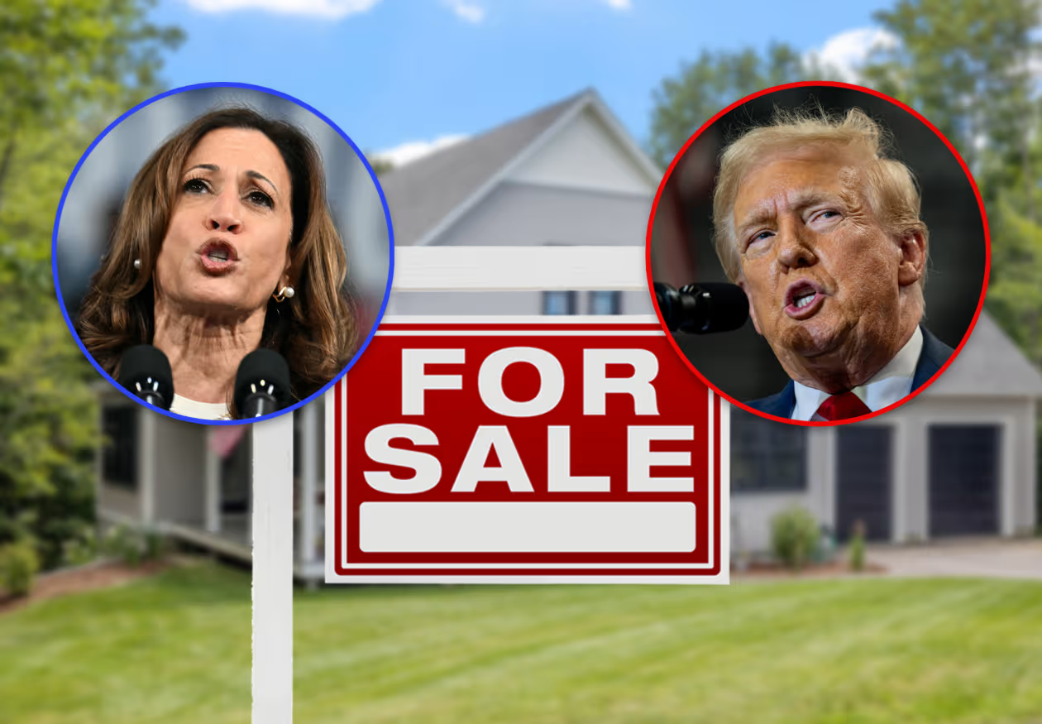

**Document 5 – The 0% house down payment plan, by Dave Granlund, *The West Central Tribune*, June 5, 2024**

*\* A no-down payment mortgage is a home loan that allows you to finance 100 percent of the home's purchase price without having to put any money down at closing.*

