LVA

En vous appuyant uniquement sur les documents du dossier thématique qui vous est proposé, vous rédigerez une synthèse répondant à la question suivante :
How is sport reflecting today’s world conflicts?
Votre synthèse comportera entre 450 et 500 mots et sera précédée d'un titre. Le nombre de mots rédigés (titre inclus) devra être indiqué à la fin de votre copie.

Ce sujet comporte les 4 documents suivants :
— un article intitulé “We need to separate sport and politics. But also recognise that they’re inseparable”, Kenan Malik, The Observer, 13 Juin 2022;
— un dessin de presse de Daniel Garcia, “Washing machine”, 17 Novembre 2022 ;
— un sondage de Pew Research Center, réalisé en Septembre 2019 ;
— un article intitulé “How World Cup politics explain the modern world”, CNN, Stephen Collinson, 23 Novembre 2022;
— un éditorial intitulé “Judge Jeanine Pirro: NFL players taking a knee, Commissioner Roger Goodell, shame on all of you”, Fox News, Jeanine Pirro, 24 Septembre 2017.

Document 1 - We need to separate sport and politics. But also recognise that they’re inseparable, Kenan Malik, The Observer, Sun 13 June 2022
“Fans don’t want politics brought into football.” Many would agree with Tory MP Lee Anderson’s sentiment. And so, he carried on, in response to England footballers “taking the knee” before a match: “For the first time in my life I will not be watching my beloved England team while they are supporting a political movement whose core principles’ aim is to undermine our way of life.”
But, wait, who is it now introducing politics into football? Those taking the knee or those who insist that to do so is helping to “undermine our way of life”? Or both? And why is it that those obsessed with flying the flag suddenly find their patriotism so thin they cannot support the national team if players do a bit of kneeling? Or even cheer on opposing teams? It seems there’s greater loyalty to the culture wars than to the nation. [...]
Most fans would probably agree that politics should be kept out of sport. We want sporting prowess to be “pure”, expressions of sublime skill or awe-inspiring endurance that are intrinsic to the sport and capture the genius of human athleticism. When we watch Lionel Messi floating through a gaggle of defenders as if with the ball fixed to his boot, or a picture-perfect cover drive from Virat Kohli, or Simone Biles’s triple-twisting double tuck in her floor routine, too fast for the eye to follow – each transfixes us by transforming our assumptions of what is humanly possible.
But sport, even in its most inspirational moments, does not exist in a vacuum. The relationship between sports and politics operates at many levels. Many sports were designed to enforce social needs, from Japanese martial arts, celebrated as a means of spiritual development and social ordering, to cricket, an instrument through which Victorians sought to teach the ruling class to rule and the plebs to obey.
The cleavage between rugby union and rugby league betrays the two codes’ class origins. The Glasgow rivalry between Celtic and Rangers is deeply invested in religious sectarianism and the politics of Irish nationalism. The current row between Russia and Ukraine over the latter’s shirt at the Euros is just the latest expression of national hostilities spilling out into the sports field. And sportsmen and women have often used their platforms to make a political point, from US sprinters Tommie Smith and John Carlos raising black-gloved fists on the podium at the 1968 Olympic games, to NFL quarterback Colin Kaeprenick who in 2016 first took the knee during the national anthem as a protest against racist violence, to Manchester United’s Paul Pogba and Amad Diallo raising a Palestinian flag after a Premier League match last month. [...]
Document 2 - Garcia, “Washing machine”, 17 November 2022
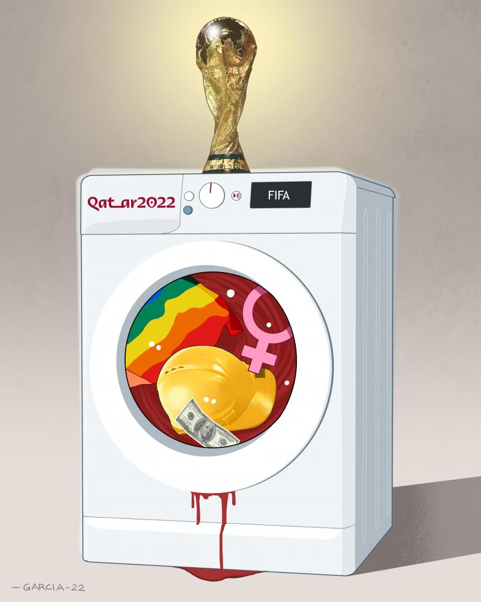
Caption: Qatar and FIFA try their best to present a squeaky-clean World Cup to the world.
Document 3 - Survey from Pew Research Center, conducted in September 2019
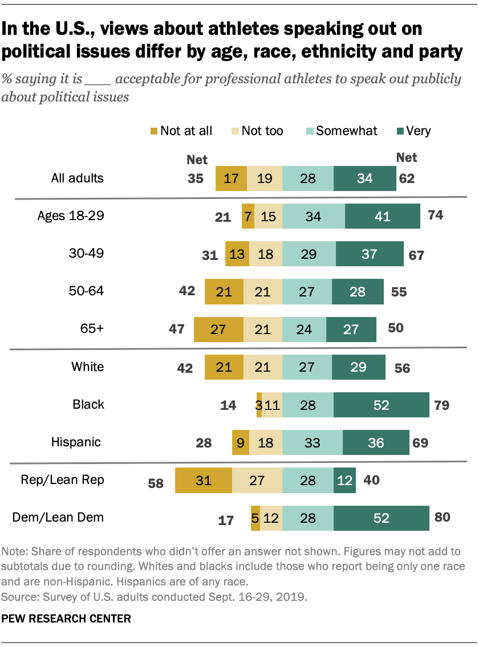
Document 4 - How World Cup politics explain the modern world
CNN, Stephen Collinson, 23 November 2022
Billions of people will watch the World Cup in Qatar, fixated on one of the world’s premier sporting festivals. But football’s governing body FIFA has also unleashed a political tempest, highlighting moral, business and geopolitical dilemmas shaping the modern world.
Disputes about FIFA thwarting a bid by European teams to support LGBTQ+ diversity, women’s rights, the treatment of immigrant workers who built air conditioned stadiums in the desert and the availability of alcohol in the Muslim nation raged since before the opening game. The dramas revived suspicions that a sport that presents itself as open to all ignored human rights and political repression in Qatar for a share of its host’s oil riches in a nation with little cultural or historical connection to the beautiful game.
Briana Scurry, a retired World Cup winning goalie for the US women’s national team, told [...] that FIFA had brought on this political storm with its choice of venue for the World Cup. “When you choose the country, you choose the consequences,” she said. [...]
The tournament in Qatar mirrors a global shift in power and especially financial muscle – from the capitals of Western Europe to new epicenters in the Middle East, India and China. And football, with its massive global appeal, is taking a huge cut. Traditional working class football clubs knitted into their communities for decades now suddenly find themselves owned by foreign energy magnates. Premier League giant Manchester City was bought by a United Arab Emirates-led group. And Newcastle United is owned by a Saudi Arabia-led consortium, forcing fans to consider (or not) the ethical dimensions of their support for their hometown clubs.
The phenomenon is known as “sports washing” in which an authoritarian nation seeking to buff up their image, despite serious criticism over their political system and human rights performance, woos the world’s top sporting stars. China was accused of such an agenda with its 2008 and 2022 Summer and Winter Olympics, where attempts at political activism largely fizzled under its repressive rule.
This World Cup, like many recent major international supporting events, is forcing fans to consider more than the final score. There’s a question here over the extent to which visiting fans should respect local traditions that infringe their own values and freedoms.
It’s not new for a global sporting event to unfold in a politically charged atmosphere. US athlete Jesse Owens, for example, undercut Adolf Hitler’s claims of a Nazi master race with his showing at the 1936 Berlin Olympics. At the 1968 Mexico Olympics, US track stars Tommie Smith and John Carlos promoted civil rights with Black power salutes from the medal podium. [...]
The sense that athletes may be held to higher moral standards than their government is also key to the current feud [...].
Ever since sport went global, it’s always reflected social, cultural and religious trends and conflicts – despite calls from purists for it to remain a safe space from politics. [...]
Document 5 - Judge Jeanine Pirro: NFL players taking a knee, Commissioner Roger Goodell, shame on all of you
Fox News, Jeanine Pirro, 24 September 2017
The biggest issue facing our country today is the tip-toeing and political correctness that has brought us to the brink of disaster in national security, politics, and sports. The question now is: do we have the fortitude, courage, and determination to stand up to those who threaten our values?
Friday night in Alabama, President Trump did just that and took no prisoners on the sports issue and the NFL players who disrespect our flag. Last year San Francisco 49ers quarterback Colin Kaepernick, who by the way is without a team this year, began the protest by taking a knee during our Star Spangled Banner.
The fallout was swift and certain. NFL Commissioner Roger Goodell called the president's comments “divisive” saying that they demonstrate an “unfortunate lack of respect for the NFL, our great game and all of our players.” He went on to say that the president exhibits “a failure to understand the overwhelming force for good our clubs and players represent in our communities.”
According to USA Today NFL player arrests are not only disproportionate to the general population, but the violence associated with these arrests is shocking. And I'm not even talking about the homicides.
And Commissioner, instead of taking sides against the national anthem, maybe you ought to think about your stock holders, your investors. Even though the stock market, thanks to President Trump is at an all-time high, there is one area that is suffering greatly. Companies that broadcast, yes, the NFL games. [...]
Here’s my take: People watch sports to get away from day-to-day stresses, work, illness, financial worries, we don't need to be reminded of political divisions.
All of a sudden, football players are lovers of the Constitution and the First Amendment – you're full of crap. And that includes Buffalo Bills running back LeSean McCoy who called the president a word that I can't say... You want to kneel, sit, or raise your fist during the national anthem, you ought to go kneel in front of a guy who has lost his limbs fighting for you so that you can call the president that!
And don't give me this crap that you guys want to support reform and stand up against social injustice. When was the last time you voted? Wrote a letter to your legislator or congressional representative? [...]America has been incredibly good to you. From the time you displayed talent in sports as a youth America allowed you to shine and become financially prosperous. There are so many of you who make tens of millions of dollars why don't you get together and take care of the social injustice instead of disrespecting our country? [...]

