**Document 1 - Coronation: How popular is the monarchy under King Charles?**

*BBC.com*, April 24, 2023, by Jane Corbin & Sean Coughlan

The monarchy is at a time of transition. The long reign of Queen Elizabeth II had significant family turmoil, but was largely a period of stability and continuity for the monarchy. There is now a new king.

But is public opinion about the monarchy changing too? Recent visits by King Charles have seen anti-monarchy protesters making their presence noisily felt, alongside those showing support for the new reign.

Those anti-monarchists have acknowledged that they would have been reluctant to carry out such protests when the late queen was alive, because of the risk of antagonising the public. But now it seems the gloves are off.

To gauge the public mood ahead of the coronation, Panorama commissioned a new YouGov opinion poll. The results suggest broad support for keeping the monarchy […].

But, below these headline figures the poll points to attitude shifts under way - with some clear popularity challenges for the new king at the start of his reign.

In particular, the monarchy seems to have a problem appealing to young people. […] [And] Indifference could be an issue as much as opposition, with 78% of the younger age group saying they were "not interested" in the Royal Family.

So what are the difficult issues facing the new reign?

The wealth of the Royal Family, at a time of cost-of-living pressures, is one factor that seems to sharply divide the age groups. […]

"The number of palaces is absurd. Frankly, you need one palace for state occasions, Buckingham Palace, and perhaps one other for when they want to retire to the country," says former Lib Dem minister and critic of royal funding, Norman Baker.

He also highlights what he claims is an overuse of helicopters and private jets when the King is "lecturing people about climate change".

Such accusations are rejected by Lord Nicholas Soames, a friend of the King's for many years, who says using a helicopter would only be for a "very good purpose" on public duties.

"This is not done as a sort of jaunt," he says.

Constitutional expert Sir Vernon Bogdanor also doesn't accept the financial criticism.

"I think the Royal Family give, on the whole, very good value for money. And the only people who receive money are those who undertake public duties."

But there are public sensitivities about spending, as highlighted in another YouGov poll last week, which found a majority of people did not believe that the government should pay for the coronation.

How much the coronation will cost, in terms of public spending, won't be revealed by the government until after the event.

There have also been recent newspaper investigations into royal funding which have questioned the boundaries of private and public funding for the royals - including the status of the duchies of Lancaster and Cornwall, estates which each generate more than £20m in profits for the royals.

According to Mr Baker, these holdings of land and property should be seen as "public assets" and "the money that they raise in terms of profit should go to the taxpayer to fund public services", instead of being "diverted into royal coffers".

In response Buckingham Palace says the Duchy of Cornwall funds the public, private and charitable activities of the heir to the throne - while the Duchy of Lancaster helps fund the sovereign so they are not otherwise a "burden on the state". […]

Questions over money might feed into doubts about how well the royals can empathise with the experiences of the public. […]

But the King has had decades of working through his charities to support disadvantaged families - and Dame Martina Milburn, former chief executive of the Prince's Trust, praised his ability to communicate with a wide range of people. "I've literally been with him in prisons, in youth offending institutes, in job centres - and he can make that connection, it is quite extraordinary," she says.

Although Graham Smith, chief executive of the anti-monarchy group Republic, suggests polling reflects an often under-reported level of opposition to the monarchy. "Across the country there are millions of people who want the monarchy abolished," he says.

Another intense area of sensitivity for the Royal Family has been perceptions of their attitudes towards race.

From the fallout with Meghan, Duchess of Sussex, to the high-profile row over the treatment of black charity founder Ngozi Fulani at a Buckingham Palace reception - it has been a thorny subject.

The scale of the challenge is suggested in the YouGov polling which found people from ethnic minority backgrounds were less likely to support the monarchy[…]

Lord Soames strongly rejects any suggestions of racism. "There's not a racist drop of blood in the King," he says.

[…] But this is also an issue affecting relations outside the UK, including the Commonwealth, where questions are being raised about the legacy of colonialism and slavery.

In a speech to Commonwealth leaders in Rwanda last year, the then Prince Charles spoke of the "depths of his personal sorrow" at the suffering caused by the slave trade.

In another speech - during last autumn's visit of the South African president, Cyril Ramaphosa - the King said: "We must acknowledge the wrongs which have shaped our past if we are to unlock the power of our common future."

But Sir Hilary Beckles - a historian in Barbados and chairman of the Caricom Reparations Commission - says more action is needed because, at present, the relationship between the monarchy and the Caribbean is "tense". […]

The polling for Panorama might raise questions about a moment of change for the monarchy.

But it's also something of a picture of continuity. The overall findings show broad support for the monarchy, alongside a sizeable minority of sceptics.

Many polls over the years have found something similar, with rises and falls alongside the changing headlines. […]

**Document 4**

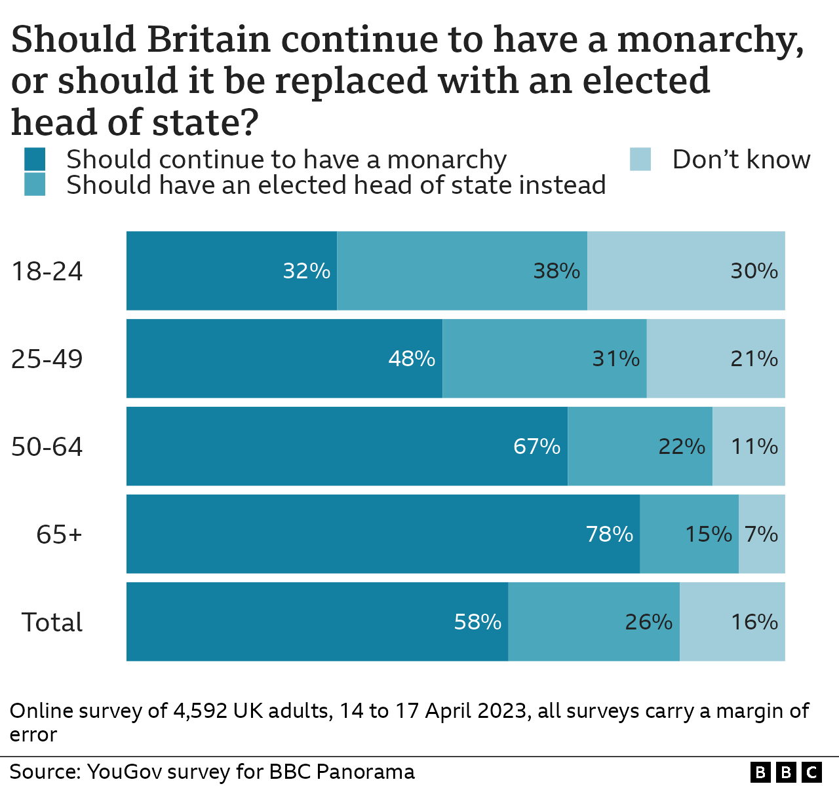

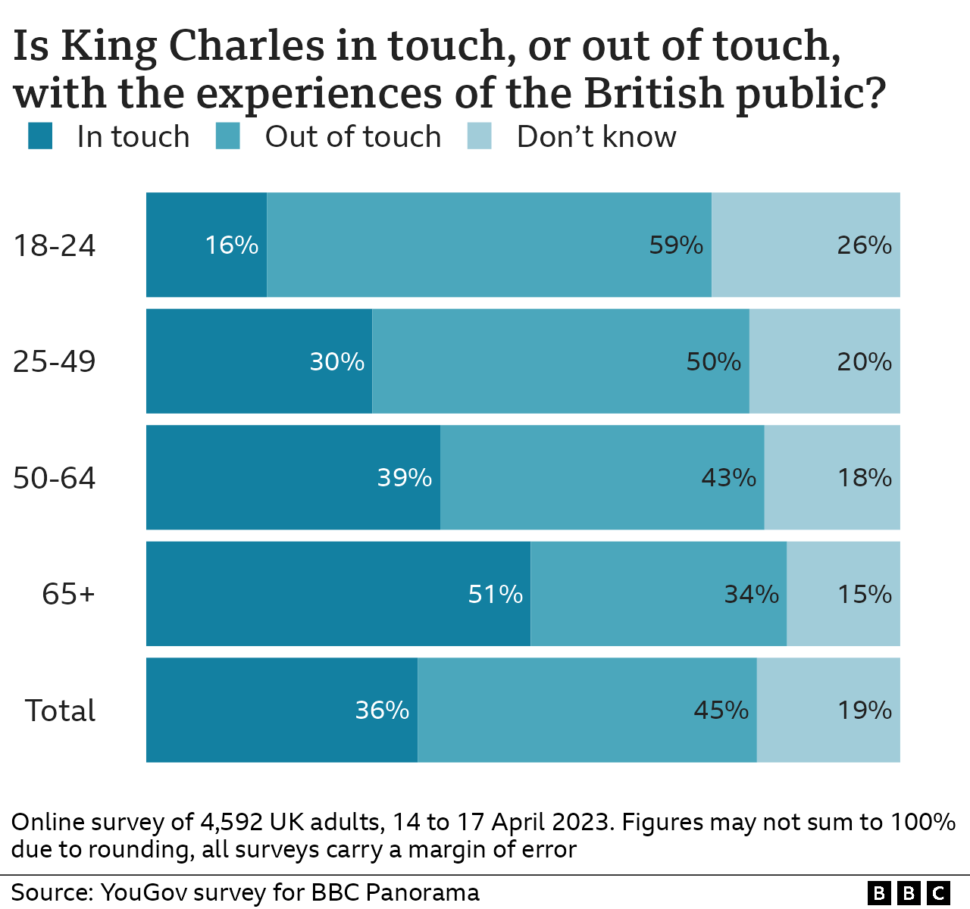

**Document 5**

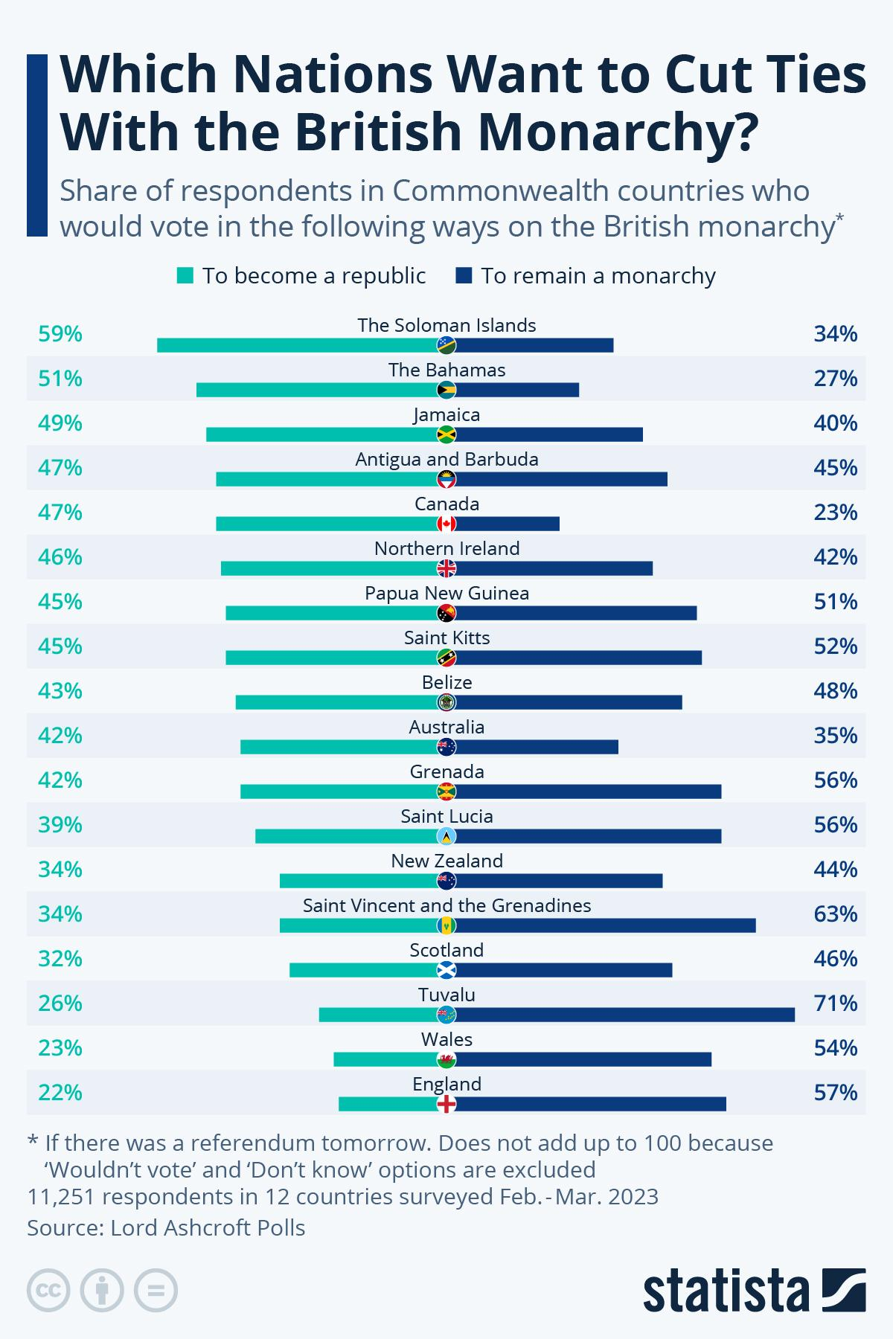

**Document 4 - Can the British monarchy survive in its gilded cage?**

By Michael Holden and Sarah Mills, *Reuters*, April 20, 2023

As Britain prepares to crown King Charles III in a ceremony with traditions dating back some 1,000 years, the monarchy confronts a question it has faced down the centuries: how does it survive in the modern world?

For the House of Windsor, that does not mean dealing with growing hostility from politicians or the public, for which there is little evidence, but rather their indifference and simply becoming negligible.

And in a world where mobile phones are ubiquitous, brutal social media commentary is rampant, and the media's voracious appetite for royal stories is insatiable, the greatest issue might be that the family themselves no longer fancy the job.

"One thing that Prince Harry has really reminded us, if we needed any, is just how incredibly painful it is to live in a cage in which you are constantly scrutinised," royal author Tina Brown told Reuters. […]

While many other European monarchies have come and gone, or are far diminished in scale and importance, the British royal family has remained remarkably resilient.

Polls show the monarchy is supported by the majority of Britons, although that backing has slipped slightly since the death of Queen Elizabeth last September, and Charles does not enjoy quite the same overwhelming popularity of his mother.

But surveys also constantly indicate the young are less bothered about the institution than older generations, and as Elizabeth herself once said, while it was hard for them to gauge public opinion, partly because of deference, "read it we must".

Republic, a group that wants to abolish the monarchy, has pointed to a poll which showed a majority of people were not interested in the coronation.

"Most of us aren't that interested, and most of us think the royals should pay," its chief executive Graham Smith said.

"Relevance is absolutely crucial to the monarchy," said Robert Hardman, a long-time royal correspondent and author of 'Queen of our Times'.

"The big threat to the future of the House of Windsor is not mobs storming the gate, it's not revolution, it's becoming irrelevant. The queen always used to say we have to be seen to be believed."

But therein lies the catch for the royals. There has long been a symbiotic relationship between the press and the royals, with papers extensively covering their engagements such that barely a day passes without an appearance on the front page of a national newspaper.

But, in return, the royals are considered public property with an expectation that they play the press "game" in return for gilded lives in palaces.

"Monarchs and their families need the media just as the media need them," Harshan Kumarasingham, senior lecturer in British politics at the University of Edinburgh.

"A monarchy exists in a very precarious existence where it can be at the centre of our adulation, but it can also be at the centre of our criticism and fears." […]

With everyone having cameras on their mobile phones, there will be even more risk of exposure for the three young children of Prince William who face having every minor misdemeanour, inappropriate comment, or embarrassing mistake captured on film. […]

However, whatever difficulties it has faced over the years, from wars, divorce, internal squabbles or even abdication, the monarchy has always shown a remarkable ability to bounce back from adversity.

"It's remarkable at adapting," Laura Clancy, a media lecturer at Lancaster University who specialises in the royals. "They've shown that they know that they need to adapt to the modern world in order to keep existing."

Whether they will want to is another matter. […]

**Document 5 – In sickness or health, a new path will be needed for the British monarchy and the nation**

*The Guardian,* by Martin Kettle, February 8, 2024

*Against the backdrop of the King’s illness, Britons remain divided: should our royal family be subject to evolution, reform or abolition?*

On this, at least, everybody can identify with King Charles. His cancer diagnosis this week is a traumatic moment, and not just for him but for his family. It has also triggered instinctive public sympathy, not least for the monarch’s refreshing relative openness about his condition. All this has fired up a powerful media story, made more irresistible by the Prince Harry subplot, that will be part of our national life for months.

But do this week’s events actually have institutional implications for the monarchy? The instant reflex of many will be to say no. The British monarchy’s recent history of adaptiveness, under Queen Elizabeth II and now Charles, points that way too. After all, “the firm” is hardwired for continuity. Seamless adaptation is what the monarchy does. It has been doing it again this week, albeit wrapped in the privileged language in which going back to work becomes the “resumption of duties”. Few politicians have any interest in questioning any aspect of this.

Yet the king’s diagnosis is still a shared national shock. It reverberates more widely than if the sufferer were you or me. It was also very unexpected. Coming so soon after the end of Elizabeth II’s unprecedentedly long reign, it poses governance questions that are unfamiliar to rulers and ruled alike. The country is not used to being presided over by a withdrawn or sick sovereign. This has set people thinking and talking. It is silly to pretend otherwise, and sillier still to disapprove of discussing it.

Looking back, this thinking and talking did not happen enough when Elizabeth II died. She had been there for so long that the transition to Charles occurred in a kind of collective disbelieving daze that the fateful moment had finally arrived. As a result, the national conversation in September 2022 tended mainly to look back to the past, not forward to the future. The new king was already a deeply familiar figure. This ensured as stable and unquestioning a transition as is possible to imagine.

This week’s intimation of royal mortality feels suddenly different. It asks us to take on board properly, in a way that remained secondary in 2022, that this royal reign will be significantly shorter than the last. It whispers insistently to us that one day – still perhaps years off, but perhaps instead disconcertingly soon – both the monarchy and its relationship with the nation will have to evolve again.

This is a bigger question than some would like to believe. Nor should it be ducked. Doubters should instead look at two opinion polls conducted in January. Each reveals a British public whose belief in the monarchy is far more lukewarm and nuanced than you might imagine from watching the news bulletins this week or from reading the papers. They remind us, in particular, that Britain needs to reckon with generational changes, both in public attitudes to the crown and among those who wear it.

The polls, by Savanta and YouGov, have produced strikingly similar headline findings. In Savanta’s poll, 48% of adults say they would prefer Britain to have a monarchy, against 32% who prefer an elected head of state, with 20% saying they don’t know. YouGov’s figures, in answer to a similarly worded question, are 45% for monarchy, 31% for an elected head of state and 24% who don’t know. Older voters are more emphatically monarchist in both polls. Among younger voters, however, there was a clear preference for replacing the monarchy with an elected head of state.

None of this should be taken to imply that Britons, even the younger ones, are bursting with republican enthusiasm. They are not. Other polling questions on monarchy also show less stark divides. But two polls in recent weeks both showing that, for the first time ever according to the Republic campaign group, the monarchy lacks the overall majority support of the population should make politicians, as well as courtiers, think. So, in particular, should the confirmation in both the polls that younger adult Britons are far less committed to the monarchy than their parents or grandparents were. And this generation gap seems to be widening.

There are also striking differences between particular parts of Britain. In the YouGov poll, there are more people in support of an elected head of state, as opposed to a monarchy, in Northern Ireland, Scotland and London. This is a reminder, nevertheless, that the monarchy is one of the relatively few British institutions that actively promotes a UK-wide sense of identity. King Charles seems to be notably well aware of this. Unionism comes very naturally to him. But how far is that true of his son Prince William, who grew up during the years when the bonds of the UK were weakening?

In his new book Fractured Union, Prof Michael Kenny of Cambridge University analyses three contrasting constitutional paths facing the UK: break-up, overarching reform and gradual evolution. Of these, he argues, the third is the most likely. But it is not the easy option. As Kenny stresses, the pragmatic evolutionary path also requires the constant management of a national dissensus, not a national consensus. It requires enormous care and sensitivity. Modern British politics has not been very good at that, to put it mildly.

The king’s cancer is a reminder that a similar choice between abolition, reform and evolution inevitably faces the monarchy. Britons are divided, not united. The public appetite for opening up these questions and examining them may be low, especially when compared with other, more pressing problems. But even if the king returns to relative health, the issues will not go away.